
Letter from Chair

Glad to see almost all of us back running, hoping the ankle gets better soon Lynda and speedy recovery for anyone else not running due to injury. Great to see more new ladies joining and best of luck with all the races coming up at the moment. Take a moment to look at the races folder in the club room and online and see if you fancy any. Whilst its not essential to race, and some of our ladies just run for pleasure or fitness, racing can be fun. AGM coming up so put it in your diary, see you there.

Antonia

Letter from Editor

My initial thoughts were that the February newsletter would be rather like the month – a bit shorter than average. However the newsletter has turned into a bumper edition: We have another excellent ‘Muscle of the Month’ section from Kirstie Skelton and an article about nutrition during a race for all our aspiring marathon runners. It’s a great month for race reports – 8 of them to be exact – 4 from the Brass Monkey and 4 from the Ferriby 10. All of them are inspiring and all of them will make you want to sign up for the next race. And Victoria has kindly volunteered a regular feature of nutritious and appealing recipes. This month’s recipes sound delicious and they are economical so start honing your cookery skills. Not only will we all be fantastic, injury-free runners but we’ll be domestic goddesses too.

Ruth

West Hull Ladies R.R.C Committee Meeting
1st February 2010

Attendees
Antonia Goodison, Victoria Voase, Debbie Watson, Amanda Dean, Karen Scott, Amy Marshall, Ruth Upfold, Laura Caley, Suzanne Clarkson, Annette Pearson, Louise Ede.

10k series
The official end of the racing season is 31st March 2010 but the last actual race is the Lincoln 10k on 21st March 2010. Amanda will therefore finalise the individual trophies, prizes, etc on 21st March 2010 and the information will be circulated to the Committee.

Annual General Meeting
The AGM will take place on 26th March 2010 and will commence at around 7.30p.m. The venue at the moment is undecided but Debbie will continue to make enquiries.

The trophies needed for the AGM are:
- Member of the Year
- 10k trophies
- Improver of the Year.

The Improver of the Year will be determined by the Committee nominating approximately 6 individuals and then a small team (including Amanda) will make the final decisions. Nominees should be someone who is a regular runner with the Club. Only those ladies who joined more than 6 months ago will be eligible. All newer ladies will be considered next year.

In respect of Member of the Year, Antonia will circulate an e-mail around the Club asking for nominees. The closing date for nominations will be 28th February 2010.

Victoria is to deal with the trophies, etc.

Ladies will also be asked to bring in a present for the raffle which will be drawn on the night. Antonia will organise the raffle tickets.

KarenS will sort out a quiz for the evening.

Committee Roles

The document detailing the role of each committee member has now been circulated and needs to be completed.

Champagne League

The Club has 10 places and priority will be given to ladies that have not run before and can compete in all 10 races. An e-mail will be circulated requesting that ladies who are interested respond.

Website

Karen is to take over the racing section of the West Hull Ladies website. She confirmed that the racing file is also up to date.

Membership

If the annual membership fee is paid by the Annual General Meeting then the price will remain £20.00. The cost after this date will increase to £22.00. There are still some ladies that have run with the Club on more than 2 or 3 occasions but have not paid any membership.

The next meeting is scheduled for Monday 1st March 2010 at 7.15p.m.

Training Officer Report

Didn’t everyone do well in the Brass Monkey and the Ferriby 10!

Not quite a report but ... Do you know that running increases your brain size ... particularly in the area which stores memory? Yet another good reason to get out and run – stops you losing the car keys.
In fact the psychological benefits of running are fantastic .... running reduces stress, anxiety and depression. It improves your confidence, relaxation and helps you sleep well. Running is a natural tranquilizer. If you are lucky you may have experienced a “runners high”. It is a feeling of extreme happiness and exhilaration. You feel euphoric. You feel you can do anything!

Goal Setting: It’s great to have so many ladies setting goals (from 10Ks to Marathons!) and heading for amazing races and even better seeing ladies encouraging and supporting each other. This is what makes a good club – supporting each other at every level.

East Hull 20: Rachael, Sara, Anna, KarenS, Victoria and Debbie are planning to join in the East Hull 20 training schedule – to run this race is a fantastic achievement. If you are not sure about it, just try keeping up with the training for a few weeks and see what happens.
Debbie will be leading out the faster runners whilst I will be leading the steadies. We will be encouraging the groups to practice eating and drinking whilst running as well as getting confidence that your body is capable of extending the distance each week.
New ladies are probably a bit in awe of the EH20 runners so it is worth knowing that most of the ladies who are planning on running this race, less than one year ago, were running 3M-5M as their distance.

Advice to new ladies: Build your mileage steadily. Your weekly mileage is more important than a distance run at this point and it is important to run regularly 3M-5M at least twice a week and preferably 3 or 4 times. Even better is run 3 times and cross train at least once. This prepares your body, strengthening your joints and muscles without straining them. Once you have a couple of months of this kind of running you will be ready to fly and you won’t believe how amazing you can be.

Advice to all .... enjoy your running and if you are finding it tough feel really proud of yourself that you still get out and do it.

Cheers,
Amanda

Tip Top Tips

Ruth: Try always to run with a mobile phone, some money and any personal details you consider relevant in case of emergencies.
February Muscle of the Month: Psoas major

Where is it? It starts in the lower back and is attached at one end to the sides of all the lumbar vertebrae (L1 – L5) as well as the last thoracic vertebra (T12). It also attaches to the discs in between the lumbar vertebrae. The muscle goes down through the groin area and attaches at its other end to the top inside section of the thigh bone (femur).
What is it? Psoas major is part of the group of muscles known as the hip flexors.
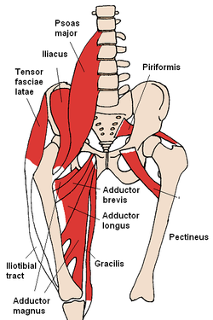
What does it do? As part of the hip flexor group, it allows us to lift our legs up, such as bringing our knees into our chest and stride out when running. It also allows us to get ourselves up when lying face upwards on our backs.
How does it get injured? This muscle generally gets injured through overuse i.e. running when we are tired, unfit or running greater distances or up longer hills than we are used to. In addition, insufficient rest or nutrition as well as lack of stretching can cause problems in this muscle.
How can Psoas injuries be treated? Very often, although Psoas major is a hip flexor, pain is felt in the lower back and into the groin. As well as massage of the lower back, I find Muscle Energy Techniques (METs) and stretching are the best methods of treatment for my patients. METs are non-invasive and used to normalise joint dysfunction and increase range of motion. The two main types of MET are Post-Isometric Relaxation (used for chronic conditions) and Reciprocal Inhibition (used for acute conditions).
How do I stretch it? The best stretch for Psoas major is a lunge stretch. Stand with your feet together then take a big step forward with one leg and then bend your front knee and sink your pelvis downwards into the stretch, pushing your hips forward and straightening your back leg NB the side being stretched is the side with the leg straight out at the back.
How do I strengthen it? Sit-ups on an incline, hanging leg raises and hip flexor exercises on a static hip machine at the gym.
Which muscle groups are related to it? The other hip flexors: Iliacus, Rectus femoris and Sartorius. Also, Quadratus Lumborum.
Quick anatomy fact: 36% of an average woman’s total body mass is made up of skeletal muscle (ie muscle that allows our joints and bones to move, rather than muscle that lines our organs), compared with 41% for an average man.
About me
I am an Advanced Remedial Massage and Manipulative therapist based in Cottingham, Hull and Beverley. I treat a variety of sports people in my clinics and I am always delighted to treat members of the West Hull Ladies running club so if you would like to book an appointment or have any questions, you can email me at kirstieannskelton@hotmail.com, call 07789 914597 or visit my website www.kirstieannskelton.com for further details.

Running Library

Using the library:Locker 18. Chose your book, write your name and date on the card and leave the card in the locker so we know where the book is.

Book List
out The Runner's Diet (Runners World), Madelyn H. Fernstrom
out Paula My Story so Far, Paula Radcliffe
out Running Made Easy, Susie Whalley
out The Complete Book of Running for Women, Claire Kowalchik
in Absolute Beginner's Guide to Half Marathon Training, Heather Hedrick
out Run Fast: How to Beat your Best Times Everytime, Hal Higdon
in The Runner's Handbook, Bob Glover
in The Competitive Runner's Handbook, Bob Glover & Shelly Lynn Glover
out Marathon: From Start to Finish, Sam Murphy
out Marathon Running for Mortals, John Bingham
out 4 Months to a 4 Hour Marathon, Dave Kuehls
out Marathon Running Beginner to Elite, Richard Nerurka

Running Magazines available to borrow from the table in the club room

Marathon Nutrition Q+A: Nick Morgan  By Nick Morgan  Discover the answers to some of your frequently-asked fuel and hydration questions with Lucozade Sport's Lead Sport Scientist Nick Morgan | 
Q. I ran the Flora London Marathon last year and took gels every 45 minutes along with water and sports drinks when they were available. Is 45 minutes about right, or too frequent or infrequent? My feeling from last year was almost that I'd taken on too much... Neil Bolton
A.Marathon runners need 30-60 g of carbohydrate per hour. A carbo gel has around 32g of carbohydrate so, in combination with the Lucozade Sport on course, a gel every 45 minutes would give you an average of 40g carbohydrate per hour, which is well within these guidelines.

Q. At what point in a race should I take my last gel? Is there a point when there's not enough time left for the body to benefit from it? Pies and Salad
A. It's never too late, because it can still enhance recovery. You also have sensors in the mouth that can give you an instant lift by taking in carbohydrate. In terms of functional benefit for the race itself though, I would suggest taking your last gel around 30 minutes before you plan to finish.
Q. You mention taking on other carbohydrate sources - for enjoyment rather than fuel. I sometimes eat fun-size Mars bars as well as carbo gels - would the protein and fat content of these be detrimental to my performance, or is it just about individual choice? Fiona C
A. Chocolate bars are a good source of carbohydrate, although they're not solely carbohydrate in the same way as carb gels are. The simple answer is: if it you like it, eat it and enjoy it. The enjoyment could even help your performance in endurance events. Many people find gels easiest though, and they are a more concentrated source of carbohydrate. Don't worry too much about your fat and protein content - you'll only be using them for energy during the race.
Q. I'm running in the Sussex Beacon Half-Marathon this weekend. When's the best time to take gels in a half-marathon? Bootsie
A. If you're going to be running for between 90 and 120 minutes, one gel should get you through - probably after around 50 minutes. If you're running for more than two hours, take two gels - the first after about 45 minutes and then another after about 90 minutes. Sweets are a good source of carbohydrate too - work out the carbohydrate content of one packet so you can calculate how much you need to meet the 30-60g/carbohydrate per hour guidelines.
Q. My marathon training includes two eight-mile runs to work each week. I do these without having any food or water first. Is there an advantage in running these shorter runs in a fasted state, to prepare for that feeling towards the end of the marathon? Bombat
A. If you don't consume anything before running in the morning, then the emphasis falls on your meal the night before. If you've eaten enough then, you could run without eating in the morning, as long as it isn't a very long or really intense run. However, if you choose to do this, what you eat for breakfast afterwards is even more important, both for aiding recovery and allowing you to get on with the rest of your day. Porridge, cereals and toast are all excellent options. Have some fruit juice for additional fluid and carbohydrate too.
Q. Do you think it's better to do all your long training runs using your marathon fuel strategy (on the basis that you are preparing your body for the actual event) or to do a few runs like this to get the strategy right and then do the rest on short rations in an effort to boost your body's fat burning? Richard_R
A. You don't need to practice your marathon fuel strategy on every long run, but the science behind promoting fat burning isn't as simple as you suggest. There is a school of thought that suggests that if you train on low carbohydrate you are increasing the stress placed on your body and this may in turn enhance your race-day performance. However, as yet this is not well accepted, and from a practical point of view, without energy you won't be able to train for the duration or at the intensity you need to in order to achieve the finish time you want. A low carbohydrate diet also increases your susceptibility to infection. You should be more concerned with using and supplying your body with carbohydrate than trying to use fat as a fuel source.
Q. After my harder sessions I use specific recovery products or chocolate milk, and it seems to make for far less muscle soreness and consequently better sessions the following day. Is the composition of these products different? Sue C
A. Recovery is very important for three reasons: to replace the carbohydrates you've used, to take on protein to help your muscles recover and to replace fluid you've lost trhough sweat. The guidelines are: 1g of carbohydate per kg of body weight as soon as possible after exercise, plus 10-20 g of protein. As for fluid, drink according to the amount of weight you've lost. Monitor your urine colour in the hours after training too. The darker the colour, the more dehydrated you are. Ideally, your urine should be a light, straw colour.
Q. Rather than worry about sweat rates - which will be different depending on the intensity of my running, the temperature, wind speed etc. - why can't I just drink when I feel thirsty? Go-KL
A. This is an interesting and ongoing debate. The most current school of thought recommends you should drink according to thirst, and to minimise a decrease in your body weight of more than 2%. But doing one of these doesn't necessarily mean the other happens. For example, drinking according to thirst might not maintain your hydration levels to the recommended standard. This is why we suggest drinking according to sweat rate. Another key concern is that people will drink too much. Hyponatraemia is very serious and runners need to ensure they don't consume more fluids than they lose in sweat.
Q. What should I eat during the taper weeks, especially the final couple of days before my marathon? I'm a slow run-walker - will the extra time on my feet have an effect on my eating plan? Happy Camper
A. Whether you are an elite, club or amateur runner, what you do during the taper period should be very similar. Key guidelines are to consume 5-7g of carbohydrate per kilogram of body weight per day. This amount is enough to help maximise carbohydrate stores but still support your tapering training. Eating breakfast is also important, as is taking on carbohydrates around training sessions
Victoria: This is a good old Deila receipe that I use quite a lot and I can prepare and clean up after within 20min.

All in one banana and walnut loaf.

These are my tips, if you don't already have some, invest in some digital scales that you can just press a reset button on so that you can continue using the same bowl to add ingredients to. Do this receipe when you have bananas that everyone is avoiding as they are starting to look a bit yuk! And if you think this is something you will do several times, invest in some loaf liners which you can get from Lakeland in Beverley (they keep for years and make things so much quicker when you make something like this and are well worth the money).

75g soft margarine or soft butter
110g caster sugar
1 large egg
225g plain flour
2 level teaspoons baking powder
4 medium bananas peeled (use 3 if they are really big)
Grated rind of 1 orange
Grated rind of 1 lemon
50g chopped walnuts

Oven setting—gas mark 4, 350 F or 180C (160c if fan)

Loaf tin approx 8.5 x 19cm, lined or put loaf liner in—if you don't have a tin the exact size just do a bit of experimenting.

Put the margarine, sugar and egg in a large mixing bowl, then sift in the flour and add the baking powder. Mix together with mixer and don't worry that it looks a bit dry. Next grate the rind of the orange and lemon onto the mixture and then mix in. Then in a separate bowl mash the bananas with a fork and then add them to the
main mixture and mix. Now add in the walnuts, mix and then transfer to your loaf tin.
Bake for approx 55 minutes until cooked

You are now done but if you fancy doing that bit extra you can scatter some walnuts on top of the mixture and sprinkle some brown sugar on top as well ( my picture doesn't include this extra element as I live with 2 health nuts so extra sugar is not on the agenda) Try and enjoy—a good runners piece of loaf, which only lasts one day in our house.
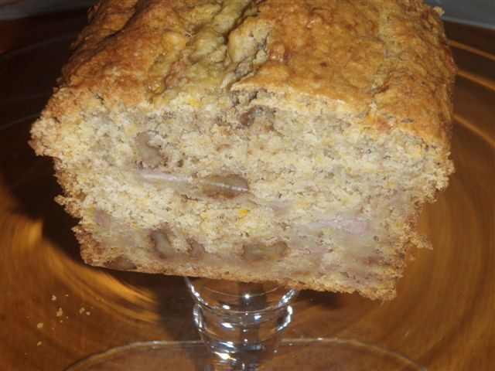

Victoria: Chicken and Vegetable curry

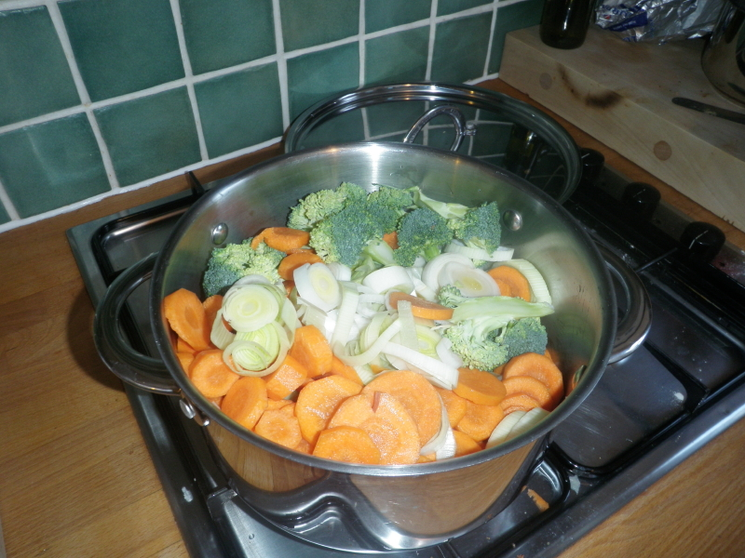

Ingredients:

Any vegetables that need using up.
Chicken breasts to suit your family’s needs.
Pataks Tikka Masala Paste (in jar—from most supermarkets and keeps forever in fridge)
A couple of vegetable stock cubes
Rice or pasta to serve

Here’s a recipe that is one of my own but ticks several boxes if you are your family’s ‘food provider’. Firstly its an excellent way to use up all vegetables that you may otherwise end up throwing away, Secondly its full of vegetables and unless you tell people what it consists of they probably wouldn’t know, (so great for getting some vegetables into family members who aren’t so keen) Thirdly, make it in advance and heat it up (great for all the family when you are running, they only have to put the pan on to warm up and hopefully they leave you some for after your run) – AND its easy.

1. Get out all vegetables that needs using up, it doesn't matter what – see photo above - roughly chop, make some stock from a vegetables stock cube or two with approx 900ml water and add to pan until half way up the veg.
2. Bring to a boil and then simmer until vegetables soft.
3. Using a blender, blend the vegetables until reasonably smooth.
4. Cut up some chicken breasts into cubes.
5. Heat some oil WITH a good dollop (tablespoon) of Pataks Tikka Masala Paste and add chicken to pan, cook for a few minutes.

6. Spoon in some of your blended vegetables until you have a sauce that looks OK to you.

7. Taste and if you would like a slightly stronger curry taste just add some more of the Masala paste, otherwise just simmer for 15 min.
8. Put some rice or pasta on to serve with.
7. Freeze any of the blended vegetables you have left over to use again, great for emergency and can be used with any of the other Pataks pastes or something similar, or any type of meat, and I've used it with fish as well.

Race Write-Ups or Write-Offs

Brass Monkey Sunday 24 January 2010

Amanda: Probably just like everyone else, I had not been able to train very well for this race. A combination of the "big Freeze" month stopping the evening runs and the weekends being booked up with other things meant that I had not run further than 8 miles since the Rudolph Romp on the 5th December. So, I started the race with no great expectations, but always hoping that the stamina would still be with me and that the shorter, harder runs I had been doing on the treadmill would be enough.
The weather was dull, cool and drizzly and I seemed to be wearing more than everyone else. In fact there were a fair number of nutcases in vest and shorts. I, sensibly, had ¾ trousers, long sleeved base layer, club vest, long sleeved top, gloves and ear warmers.
It was quite a squeeze getting into the pen towards the front and the main thing when we set off was not to trip up. We arrived at mile marker 1 and my time was spot on for the elusive sub 90min half marathon i.e. 6m 50s. I then managed not to check my watch again until the 5 mile marker and simply worked on producing a hard working but reasonably comfortable pace. At 5 miles I was 15secs off the sub-90 target. It is actually quite a boring route but I managed to day dream to distract myself. Next watch check was aimed at 8miles but long before that there was a big timer which said 44:24. I thought wow great half way time, but it wasn’t a mid way check ... if it had been I would have done 6m40s per mile for 1.5M from 5M then 8m per mile for the next 1.5M bringing me to 8M. So a confusing time check.
My time at 8M confirmed I had dropped to just a bit slower than 7m/mile. But I was not down hearted, still enjoying it, feeling strong and still in with a good chance of a PB. I was thinking of keeping this pace to 10M then upping it a bit. Of course, by 10M I was just interested in keeping my current pace and not fading. And by 11M I was doing that bit where you are willing the end to appear. And, eventually, it did. I attempted to "up it" as I headed for the end but there wasn’t any up left in me. I went through the finish in 1:33:04 which was more or less the same time as last year but later I was really pleased to find my chip time brought me into 92mins.... I had begun to think I could never get faster than 93mins.
Staggered through the finish, stomach nearly deciding to exit its contents. Picked up a sweatshirt, goody bag and a drink. Chatted to a runner then quickly changed in time to get back to cheer Anna in, next Antonia and a couple of minutes later very happy runners Shelli and KarenS.
I wasn’t sure I would get a prize as it is a very competitive race so was pleased to find I was first FV50 (a FV55 was faster though). KarenS, Shelli and Anna stayed with me for the presentation which I really appreciated. Some of the times are awesome and all of the veterans look about 10 years younger than their ages. I hope I can be still running when in the FV65 category! I always get nervous when called up for a prize. This time. when West Hull Ladies was called out there was a great cheer from the crowd, we think because Hull was mentioned. I was so nervous I grabbed the Mayor’s hand and shook that. “Not me” he said and propelled me to the person who was giving the prize out and I shook his hand too and scuttled back to my seat in relief.
Do I recommend this race? Well, for a good time it’s a great race but it is a bit boring. Flat barring the fly over and a bridge and running through mostly empty flat countryside. We go through one village. However, it is well organised and the facilities are great – lots of ladies loos.

Anna: Brass Monkeys half marathon took one day to sell out. Luckily Shelli, Karen, Amanda, Antonia and I had managed to get numbers! So we planned what training we would do, but of course that all went out of the window due to the snow! With little preparation and minimal training the day finally arrived and it was fair to say that we were all extremely nervous (except Amanda probably...). Karen, Shelli and I travelled to York together and we arrived a good hour and a half early. This was great and gave us time to sit down, relax and have a quick cup of coffee to boost our energy levels (as I student I thought 6am was a time to be going to bed not getting up!!!!). Whilst waiting I started to get REALLY nervous. I’d never seen so many compression socks, skin wearing, bib donning, short short wearing joggers in my life! And compression socks meant one thing...SERIOUS RUNNERS! So what was I doing there in my uniform more mile fluffy tights and Karimor tshirt...!! Practically everyone was wearing a club vest and people had come from miles away! People were doing stretches and jogging around the room and tucking energy gels into their short short pockets. Karen, Shelley and I were stood there probably talking about anything but running....in fact we were probably chatting about the massive greasy Chinese meals we were going to eat when we'd finished the race. Some of these runners were seriously a different breed of people. After a tense 15 minutes of feeling adequately out of place we were told to make our way to the starting line where we had to stand at different poles. We stood at a pole which said Sub 2 hrs 30 on it, hoping to get a time of roughly this. We now started to see more "normal" runners who seemed just as nervous as us and many told us this was also their first half marathon which made us feel a millions times better. The race itself was pretty uneventful. Had the usual elated feeling when taking over some big strapping muscley men and felt comfortable throughout the race. The last 3 miles were tough but not too horrible. Running over the finishing line in under 2 hours was awesome! And the free jumper and chocolate we were given were gratefully received.

I had an awesome time at this race and definately want to do it again! Half marathon sounds a long way but it’s not too bad at all. In fact I think I prefer it to a 10k. Once you settle into a pace it's almost fun. I then spent the rest of the day at work bragging about how awesome I am. After work I then attended the Tesco Christmas party where I went with a fiver and came home with change but got ridiculously drunk...hmmmm perhaps I should always run before I drink, maybe my loan would last a little longer then! I can't wait to do another half marathon and hopefully more ladies will also be up for it too!

P.S. If I was over 60 I’d have won a prize with my time!!!! (Roll on 40 years time :-) )

Karen: This time last year I only though the London Marathon, Race for Life and the Great North Run existed…how much I have learnt!!

These last two weekends I have experienced two fantastic races both very different:

Brass Monkeys Half Marathon

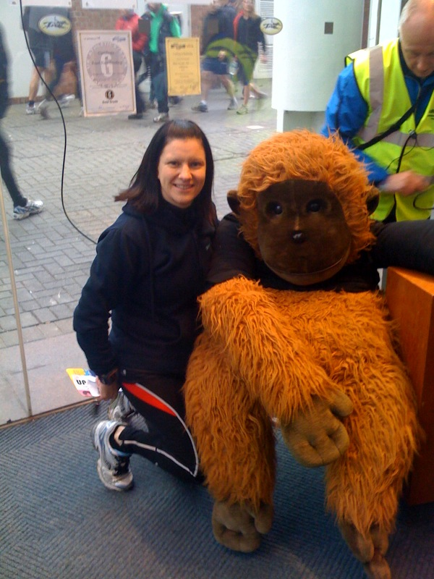
6.10am…my husband rings to wish me luck in my first half marathon. What am I I doing!!

7.30am…Shelli and Anna arrived at my house and off we went to York. I had offered to drive to keep me awake and to keep my nerves at bay.

8.30am…arrived at York racecourse and went in to collect our race chips. Fairly quiet initially but then the runners kept rolling in. The nerves hadn’t really hit me yet. The toilet queues sorted that out when listening to others discussing the race and the training they had done. We went back to the car to get prepared for the race via the ‘Brass Monkey’ and I just couldn’t resist having this photo taken!!

9.45am…last trip to the ladies and now the nerves had kicked in. Why did I sign up for this race??

10.00am…the crowds began to move and I really didn’t know how I was going to make it round this distance. Anna went flying off whilst me and Shelli had made the decision to take a steady run together. We had placed ourselves at the 2hr 30mins marker hoping we would make it round in that time.

Half Marathon…I was still in shock the first few miles at what I had set out to do. This time last year running wasn’t even part of my vocabulary never mind anything I planned on taking up in the future. The weather was perfect – a slight drizzle and no wind. Me and Shelli felt really strong. We realised that our steady pace was working really well as we were now starting to overtake those who had possibly set off too quick. I had my Garmin on so I could keep track of our progress – we were averaging 9 and half minute miles and under. In the past I hadn’t actually run further than 9 miles in one go so I was starting to panic a little once we hit the 9 mile mark because I wasn’t sure how my body was going to cope. The flat course did help and each time we past a mile marker me and Shelli counted down. I really don’t know where I found the energy from to complete the last 4 miles. Shelli was my rock around the course. The last mile felt like forever – I wished the marshals on that last stretch would stop saying ‘just a little bit further now’ - but when we turned back into the racecourse, it had all been worth it. A small surge of energy came from somewhere. Me and Shelli just went for it and finished together in 2 hours 4 minutes and 17 seconds. We totally underestimated our ability by half an hour!!

After…wow what a fantastic run!! That was my furthest distance in one go ever and I felt great. I don’t think it had really hit me until I spoke to my husband to tell him I’d finished and what my time was. I really enjoyed waiting with Shelli, Anna and Amanda to see the results and prizes being awarded…a big cheer for Amanda coming first in her category. I couldn’t believe the ages of a lot of the runners when the categories were being read out – the over 70’s should be an inspiration to us all!! I will definitely be applying again next year…and I went straight home from this race to get signed up for the Chris Hoy Edinburgh Half in April!!

Antonia: Well I was not expecting to do a half marathon and Ruth kindly let me have her number as she was returning from injury. I went to spectate last years Brass Monkey and cheer on our ladies but didn’t race it as I was 8 months pregnant with James but I made a secret promise to myself that next year I would be back and race it. I did Great North Run back in 09 and was upset that I didn’t PB, I was about 40 seconds slower and my husband said "maybe you are just not cut out to do well in a half marathon!"".

It put me off actually entering another Half but when I considered it that type of comment is just the thing to spur me, negative thoughts like that!! So when the opportunity came up to do a last-minute half marathon then I took it without a second thought. That was the easy bit.
Driving up on the day and seeing the mile markers already out was a bit daunting, especially on the hilly flyover near the end!! I arrived not properly prepared as it had been one of those busy weekends and I was over laden with inappropriate bags and didn’t have my trusty Lucozade and habitual banana but tried not to let it mentally affect me. Racing it I really enjoyed the first 7 miles and when I saw the timer at the halfway point it was 58 minutes so I thought I can so do this. By the time I got to mile 10 though I was starting to feel the effects of not enough carbs and having said out loud" this time next Sunday we will have finished the Ferriby 10 !" to my running partner I lost my mojo a bit. I had a bit of a walk to sort out my breathing, still struggling racing with my asthma, but then a really jolly Karen and Shelli trotted by and were so very encouraging I set off running again. Its things like that that make running as part of a club so special and rewarding. I have no idea where I pulled it from but miles 10 to 11 were awful but then I started to pick up my pace a bit and actually overtook quite a lot of people and the crowd were saying that was why was I still smiling!! The flyover hill was tough but you could still see the racecourse so the last bit passed like a blur then Amanda's voice, I hadn't even seen her yet, shook me into trying a little sprint finish and I was so happy to have PB'd at the end of it by almost 9 minutes!!!

Ferriby 10 Sunday 31 January 2010

Karen: This was a very different race to last week…my most challenging physically and mentally to date. Me and Shelli decided to run this race together as we have now realised how much having a racing partner by your side helps especially after Brass Monkeys. Sara and Rachael were in front and we somehow managed to stay together as a pack throughout the race.

I did feel like the weak link at times as the first part of the race appeared to take it out of me. I didn’t realise this until we left the steady ‘incline’ behind!! Shelli stayed with me and I managed to pull myself together and we eventually got back into our pack. My bag of Jelly Babies really helped…I’d made sure I had packed a Jelly Baby for each mile of the race!!

We had been running a steady race so we knew/hoped we had enough in our legs to carry us up the part of the race we had been trying to block out of our minds for the last 9 miles!! We all arrived at the bottom of the Skidby Mill hill and dug deep – me especially – I thought they were going to have to leave me but Shelli talked me up it. Sara and Rachael just stretched ahead and we all ran past a number of runners who had been ‘beaten’ by the steep incline and were walking up it. The finish line was a very welcoming sight…

Before starting the race, I was looking at a time of 1 hour and 40 minutes so when I turned the corner and realised that I had knocked more than 5 minutes off this I was ecstatic!! I really don’t know where I had found the energy to run round the course in that time considering I had only run Brass Monkeys Half the week before. This was a hard course but I completed it and it’s always a great feeling when you pass through that finishing line.

Looking forward to my next challenge…Snake Lane 10 in 4 weeks time!!

Antonia: A week after the Brass Monkeys Race in which I PB'd my half marathon time by 9 minutes!!!, I was a little disappointed that I had not entered the Ferriby 10 before it filled up. Then fortunately for me I was offered a number for it so I managed to get the number changed to my name so a great thank you to Lynda and hope the ankle gets better quick with your physio!

Anyway I had previously done the Ferriby 10 in 2008 so I knew a little bit more of what to expect this time! I had absolutely hated it the first time and was determined to try and be a little bit quicker than the 98 minutes and 4 seconds I completed it in previously. I decided to take it easy and started right at the back so I didn’t unwittingly get carried along too fast and am trying to "pace" run to help me with my marathon. I had built up a picture in my head of what the first 5 miles would be like and was pleasantly surprised by how different it seemed today and as much as I hate hills, and I really do hate hills, It seemed a bit easier than I remembered! As we got to the 5 mile mark I was called in as runner number 412 at the highest point . I thought, I'm not having that!!!

Knowing that from that point on it was mostly downhill I looked ahead and saw a man in fluorescent yellow quite a few runners ahead and said to myself, If you can see him, you can have him! So that was my target, I still took it steady and picked off the runners and counted down the numbers as I went and slowly by mile 8 I had got down to 401 place and could still see the fluoro guy! Now I don't know about you but what’s 1 more runner to get me to 400, but why not go for 399 to be under the 400!! I still maintained my pace and sorted my breathing out and just before the start of the final hill I caught up with the fluoro guy and hearing Amanda calling my name I gave a quick thumbs up for the camera and then Steve from City of Hull shouted like a foghorn, he had threatened to do so previously, and I got a second wind as we went up the hill, and me muttering something along the lines of I hate hills!! I set off up the hill, head slightly down and promised myself that I couldn't look up until I reached the second clearing. I was vaguely aware of passing people but my main concentration was making sure my hastily swigged Lucozade at mile 8 would stay down!! As I got to the top I peeked a look at the clock and could see it said 1:28 and counting. At that point I couldn't equate that to minutes and initially thought it meant I had not PB'd and had actually taken about 4 minutes longer than last time. As I crossed the finish though and they read out the time I realised that I had got 88mins 54 seconds and had got another PB by 9 minutes 48 seconds!! Loads of support and cheers and hugs at the end made it a very happy and worthwhile day. I always say I am not competitive and only ever compete against myself as I am the only one who can change my times on the day but the support and great feeling of belonging to that wonderful club of competitive runners is one competiton I can't win!!

Sara: I was bit nervous at the start as Rach and I had done a dummy run of the course a week before, unbeknown to us we had missed the hardest part of the course out, which looking back now was probably a good thing as if we had run that bit I would have been even more apprehensive about the race!
Rachael and I set off together and within no time at all Shelli and Karen had joined us and we stuck together for the rest of the race. This was great as we spurred each other on. After the first five miles, the run became easier as there were some nice downhill moments and some good flat running. However we were all trying to ignore the fact that we had a mountain to climb at the end! At the 9 mile marker the nerves really started to kick in knowing that the hill was fast approaching. We tried to look at it positively - once up it, was the finish! It was great to have some team-mates around me as I think if I had been running on my own I would have definitely stopped and walked up the hill, but we all stuck together and all ran. I definitely felt a sense of achievement at the end and Rach and I are now considering the East Hull 20.

Well done to all the West Hull Ladies who ran the race!

Amanda: Brass Monkey was the Sunday before so I had a very light running week and was expecting my legs to be nicely recovered. Anna gave me a lift to the race which was great. Found all the other West Hull Ladies – Rachael looking seriously scared, Sara not far short. Shelli and KarenS a bit more together .... well they had run the Brass Monkey the previous week so they were getting used to racing.

Anna and I jogged up the hill to the start, too cold for me to walk. A lovely day but very cold, not my ideal racing conditions. Soon off and I started to enjoy it as I warmed up. Ear warmers and gloves came off around 3 miles but still glad of my 3 layers of upper body clothing and the fleece lined tracksters. By 4 miles my legs were feeling quite tight when they should really have been thoroughly warm and bouncy. I arrived at the half way point at 36:38 which isn’t too bad a time but would make the idea of sub 70 quite an ask. Swept down hill and with the wind behind was starting to feel quite warm... in fact a bit too warm, maybe a little over dressed.
49:55 at the 7 mile marker which meant I had pulled 43 seconds back but not enough bearing in mind “killer hill”. As the route flattened out the stiffness in my legs, particularly my left calf and hamstring, was starting to pull and although my breathing was fine and I felt I had plenty of energy it felt like my legs would not turn – they needed oiling.
Just over 64 mins at 9 miles so well off the mark now. Dropped my jacket at the bottom of “killer hill” and headed up ... running first, then pacing. Count 100 hundred breaths then look up. Arg not even half way ... now do it again ... still not at the top. Count, count, keep it going, cheer from Suzanne ... finally the funnel ahead.... through the timer and relief. Stomach heaves a bit then settles. Not bad it’s been much worse at the top of that hill. Legs seizing up ... can barely move, feels like they want to snap! Apparently you should learn something from every race you do. I learnt, “don’t race two weekends in a row, my legs cannot take it”.

T Shirt collected up. Drink, then headed down killer hill very slooooowly (not so scary on the way down) - to collect my discarded jacket and cheer in first Anna, then Annette then Antonia (just because our names begin with A doesn’t mean we have to be first ☺ home). Back up the hill and soon after Rachael and Sara came in – Rachael’s face displaying pain and determination in equal amounts then Shelli and KarenS who looked to be enjoying it - or was it just relief to be at the top?

Well done to everyone ... because it is a really tough 10 miles, Snake Lane will be easy peasy after this one.

Back for the prize giving and very pleased to get 1st in the FV45-FV55 category.

2010 Racing and Running Events

Event | Distance | Date | Where | Entry Fee
Snake Lane 10 | 10 miles | Sunday 28th February | Pocklington  @ 11am | FULL
Sport Relief Mile  Lincoln 10K  East Hull 20 | 1, 3 or 6 miles  6.2 miles  20 miles | Sunday 21st March  Sunday 21st March  Sunday 28th March | Hull City Centre  @11am & 11.45am  Lincoln City Centre  @11am  East Hull  @ 10am | £5  Club Member - £14  Unattached - £16  Club Member - £14  Unattached - £16
Hornsea 1/3 Marathon | 8.7 miles | Sunday 11th April | Hornsea  @11am | Club Member - £9  Unattached - £11
Beverley 10K  Jane Tomlinson Hull 10K | 6.2 miles  6.2 miles | Sunday 9th May  Sunday 23rd May | Beverley  @11.15am  Hull City Centre  @ 9am | Club Member - £9  Unattached - £11  Club Member - £18  Unattached - £20
Race For Life  Humber Bridge 10K  Castle Howard Trail 10K  Humber Bridge Half | 3.1 miles  6.2 miles  6.2 miles | Sunday 6th June  Sunday 6th June  Sunday 13th June  Sunday 27th June | Costello Stadium  @11am  To follow…  Castle Howard  @ 11.15am  Humber Bridge  @ 10.30am | £12.99  To follow…  Club Member - £8  Unattached - £10  Club Member - £18  Unattached - £20
** Dates/times are subject to change **

If you want any further information about these races, races out of this region or know of any races not mentioned above please get in touch via West Hull Ladies e-mail and mark your e-mails for the attention of ‘Karen S’.

Please let me know if you have/are going to enter a race as it may give others that little bit of encouragement to get signed up. Give training purpose…sign up for a race, train regular with the club and this will help you to stay motivated as a West Hull Ladies runner.

The Race File in the club room now has a section for you to let us know what races you are signing up for…since joining the club in August I have run five races as a West Hull Lady, including my first half marathon(!) and have thoroughly enjoyed these experiences. I’m already signed up for 3 more half marathons this year – Edinburgh, Humber Bridge and I’ve managed to gain a place through the early ballot for the Great North Run!!
Karen S, Racing Officer

NOTE: Club Vests must be worn at any races you enter under the West Hull Ladies running club name

Clubwear prices

Vest - £15.00
T- shirt - £16.50
Hoodie - £14.00
Jacket - £24.50

All the above are ordered on request and must be paid for at time of ordering.
To place an order please get in touch via West Hull Ladies e-mail and mark your e-mails for the attention of Victoria.

